YRI Digital Guide -
General Website Guidelines

Version 2.0

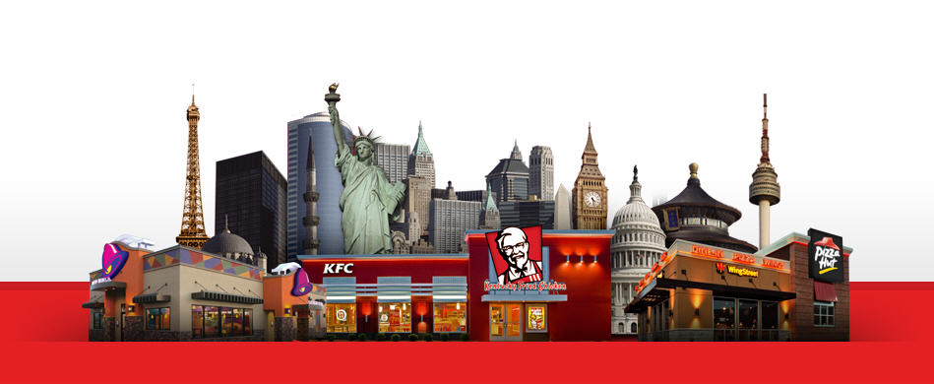

Revision History
Date | Version | Author | Description
Dec. 12, 2012 | 1.0 | Sunil Patel | Initial version.
Mar. 12, 2013 | 2.0 | Sunil Patel | Menu - added more examples from best practice flow.  Checkout – added explanation on why YUM is asking for customer information even though on guest flow.  Payment – added pre-population of fields.

Table of Contents

1. Introduction 4
1.1. Purpose 4
1.2. Scope 4
2. Selecting Partners 5
3. Best Practice Flow 6
3.1. Search Engine Optimization 6
3.2. Occasion 7
3.3. Location 10
3.4. Menu 11
3.5. Checkout 14
3.6. Payment 16
3.7. Confirmation 17
3.8. Other Guidelines 18

Introduction

Purpose
The purpose of this document is to serve as general guidelines for digital ordering. It is not intended as final requirements but rather best practice guidelines to used as appropriate for the given Market/Brand.

Scope
v1.0 covers desktop websites. Admin and mobile will be added in future versions of the guide.

Selecting Partners


  - Have in place non-disclosure agreements.
  - Share as part of requirements: this best practices guide, website design theme frames, YUM Global Security guidelines, Google Analytics tagging guideline.
  - Require service level agreements (SLAs) for uptime.
  - Require penalties for outages.
  - Require regular security vulnerability scanning and resolution of any vulnerabilities.
  - Require digital connectivity (APIs or web services) for integration with POS, payment providers, CRM system, etc.
  - Website domain name should be owned by the YUM entity, not the partner.

Best Practice Flow

Search Engine Optimization


  - Key SEO pages are homepage, product, deal and store landing pages
  - Images/Videos should have alt/meta tags since images/videos can’t be indexed
  - URL – keyword should be in folder/filename path, e.g. pizzahut.com/deals.html
  - Page Title – every page should have descriptive page title, e.g. “Pizza Hut – Pizza Deals”
  - Meta Description Tag – used as the snippet on search results pages, e.g. “Find pizza coupons and deals online for your favorite pizzas”
  - Register your store locations with Google Plus Local (formerly Google Places) so stores show up as direct links and with on map.

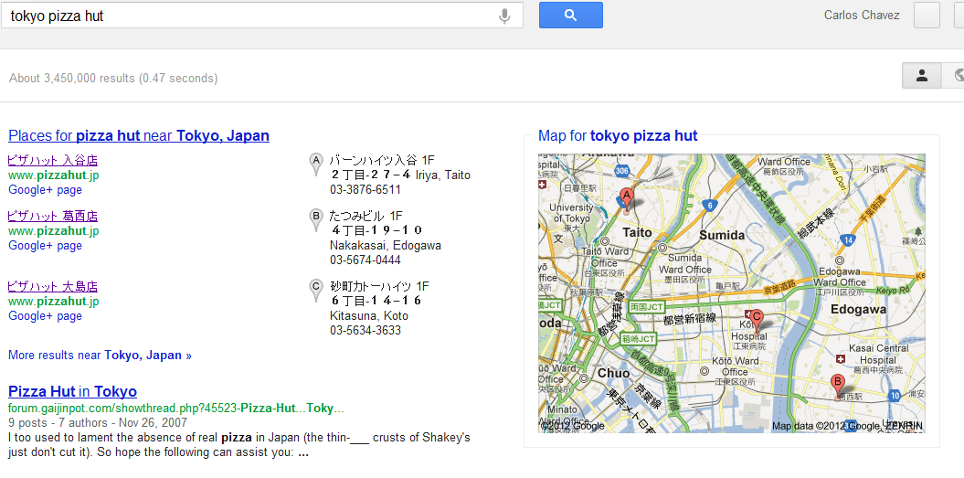

Occasion

  - Allow selection of multiple Languages if applicable.
  - Allow user to select delivery or takeaway order at start of order process.
  - System should recognize the correct delivery store based on the customer address.
  - Consider use of digital trade zones to identify the correct delivery store.
  - Allow user to login or to create an account.
  - User should be told benefits of creating an account to promote registration.
  - Mandatory fields should be kept at a minimal (name, address, address location type (home, work, etc), email address, phone number(s) and type (mobile, home, etc), password, opt-in for Marketing emails.
  - Additional optional fields can be displayed in user’s profile or at end of an order, not at registration during order flow.
  - Allow forgot password functionality.
  - Allow for Remember Me functionality to save the username (but not password).

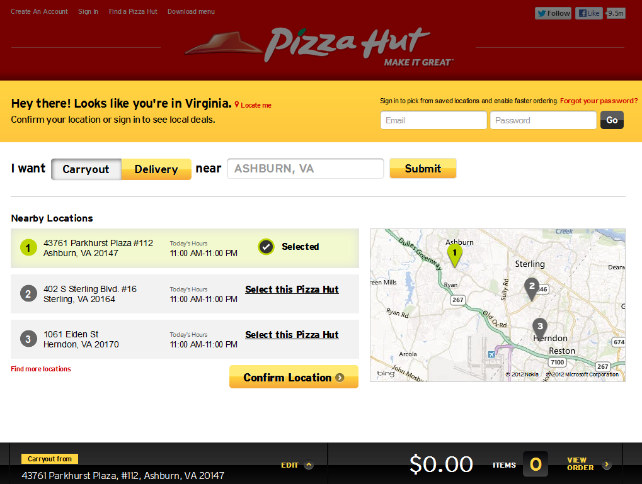

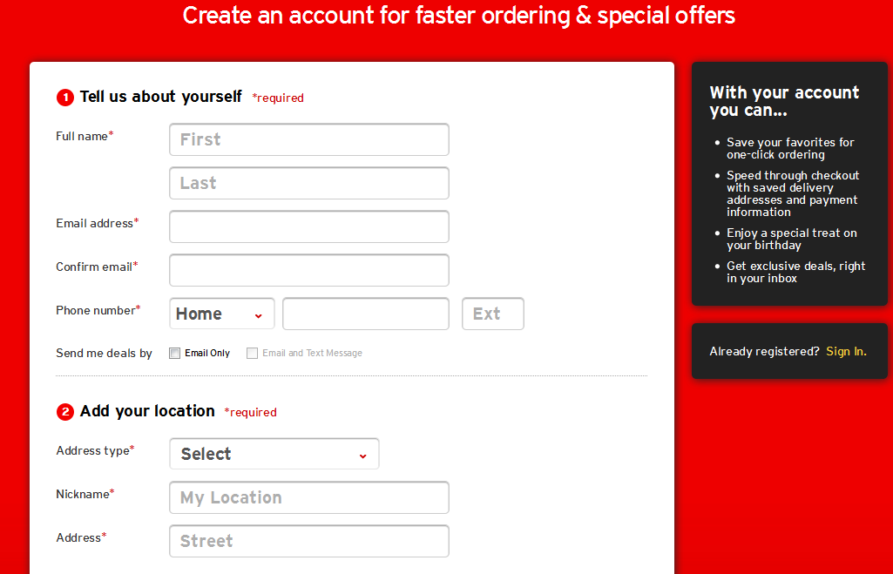

Location

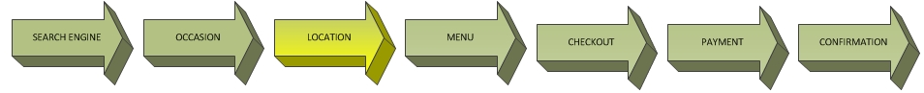

  - Default to preferred store (logged-in user profile or GPS/cookie for guest user)
  - Allow user to search for a store by entering address data. Allow user to enter full or partial address information, e.g. just entering City, Postal Code.
  - Display store results, three to maximum five stores at a time.
  - Display store hours, indicate if store is closed or close to closing time (e.g. within 30 minutes of closing).
  - Allow user to select current or future order.

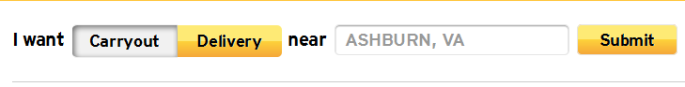

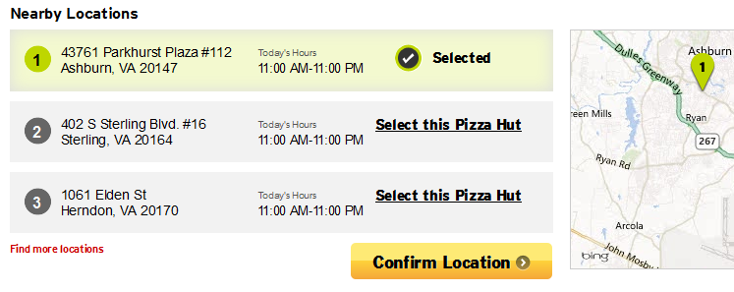

Menu



  - Display menu and pricing specific to the selected store.
  - When a Pizza is selected, visibly identify ingredient toppings on the screen.
  - Display nutritional information if required by law.
  - Allow customer to select quantity of one or more for the same item.
  - Allow for selecting a favorite product and quick reorder of the favorites.
  - System should feature a "shopping basket” with pricing, coupons, taxes, delivery charge in a fixed location on each page.
  - At the beginning of the order process system should show the estimated take away time.
  - At the beginning of the order, if customer selects a deal offering a combination of items, the system will direct the customer through the order process of each item to satisfy the coupon/meal deal requirements.

Design / Layout tips:
  - Place tiles of greater importance in top row, e.g. emphasis on deals & promotions. Most Markets should order tile emphasizing the top row, left to right.
  - In order to enable quick ordering, consider for logged-in users, displaying their Favorites. For guest users, considering displaying Most Popular ordered items.
  - Use imagery as much as possible as it is a key element in retail food conversion. Use quality images but target a filesize of less than 50 kilobytes to minimize page load time.
  - Use descriptive text for product details, make it sound enticing by appealing to multiple senses (taste, sight, smell, touch, hearing).
  - Refer to the YRI Digital Guide - Suggestive Selling Guide as well.

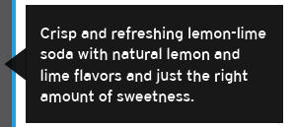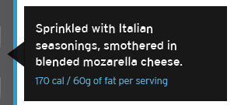
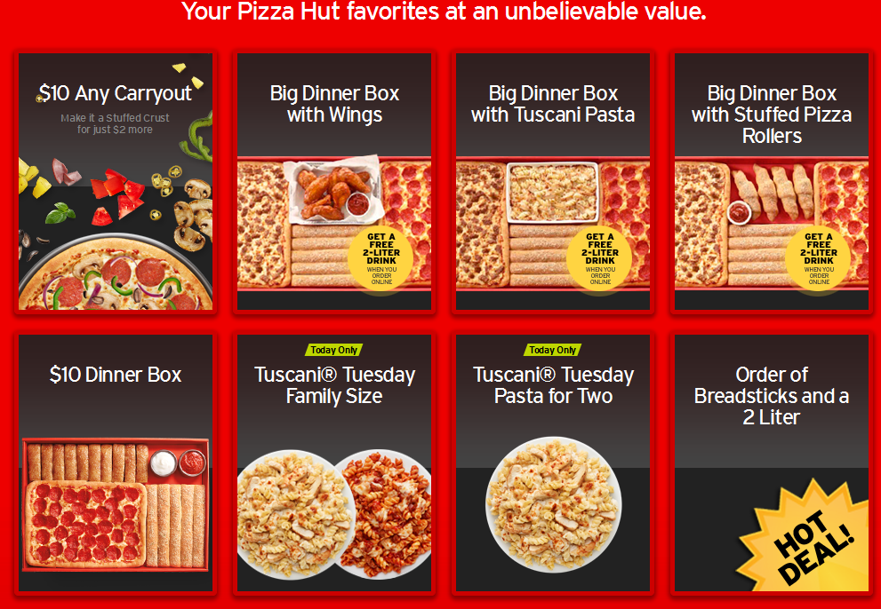

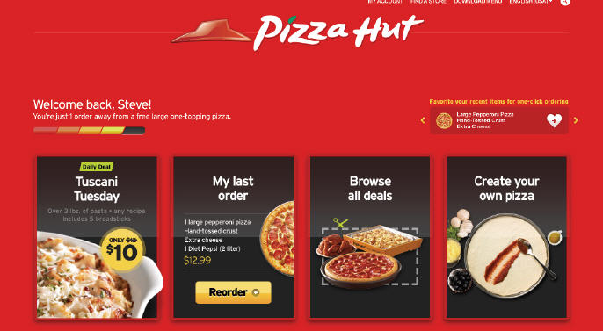
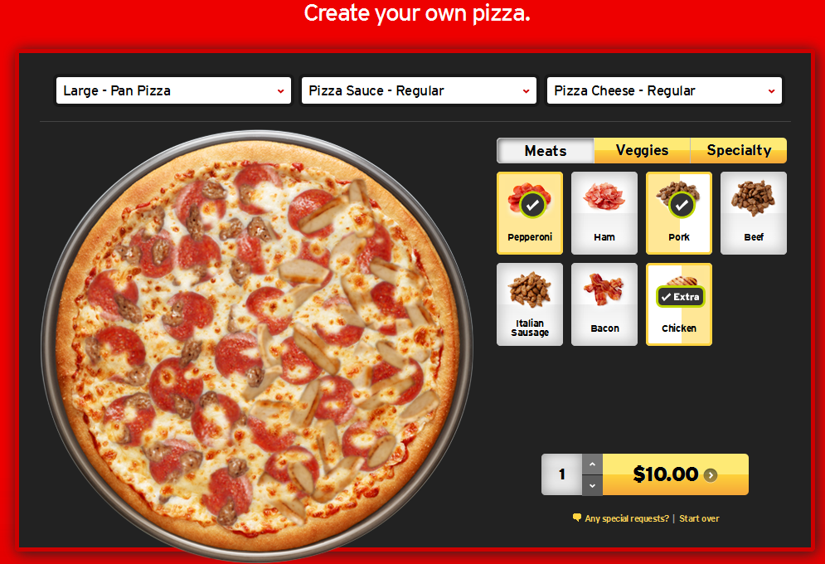

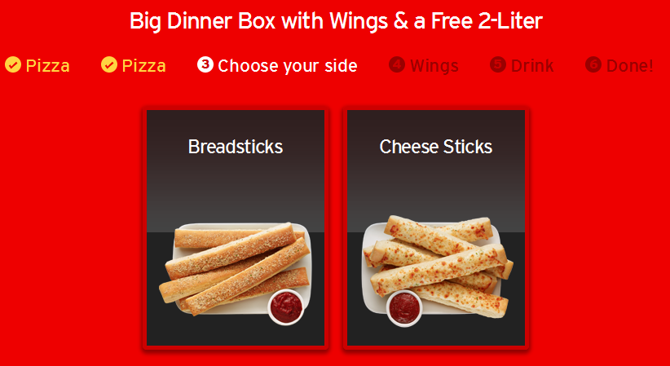

Checkout



  - Enable intelligent upsell, meaning suggest product items based on cart contents.
  - Enable upsell each time product is added to cart and/or during checkout process.
  - Allow guest checkout (user doesn’t need to register/login to place an order).
  - Communicate to the user why personal information is being asked for in the guest flow. State that an order confirmation (receipt) will be emailed and phone number is needed in case there are questions on the order or delivery address. Make reference to the privacy policy and opt-in preference. Meaning the customer will not get Marketing emails unless they elected to receive them.
  - Allow for delivery charge if applicable, display as separate line item.
  - Allow for all taxes, ideally display as separate line item.
  - Allow for customer comments if operationally supported.
  - Allow for a user to enter coupons/vouchers.
  - All passing of coupons/vouchers via URL (used with online ads & email campaigns).

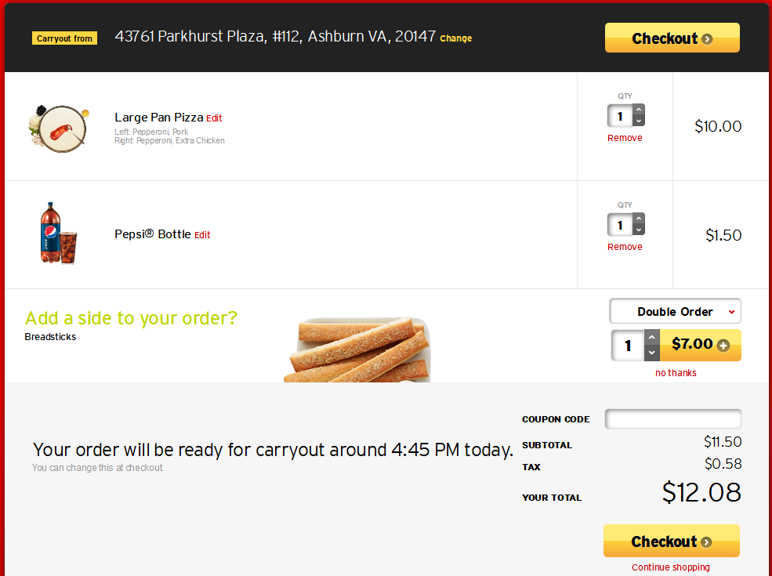
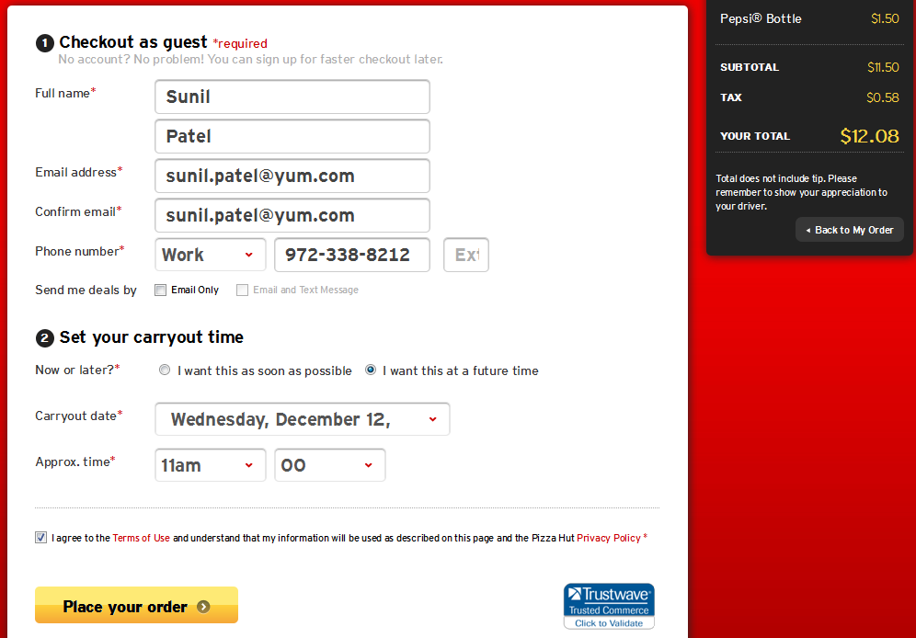

Payment

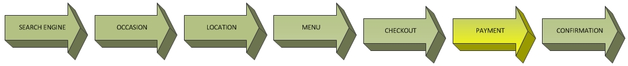

  - Pre-populate as many fields as possible, even when in a guest flow.
  - Allow for appropriate payment types (credit card, cash, gift card, etc)
  - If credit cards are accepted, the system must be PCI Compliant.

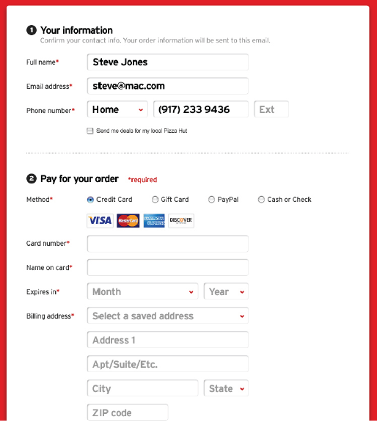

Confirmation

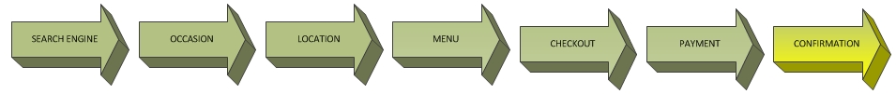

  - Display order confirmation with final delivery time/order ready for pickup time.
  - Send an email with order confirmation.
  - Allow for order status tracking if operationally possible.
  - Consider allowing customers to opt-in to receive SMS updates on their order, comply with any privacy laws.

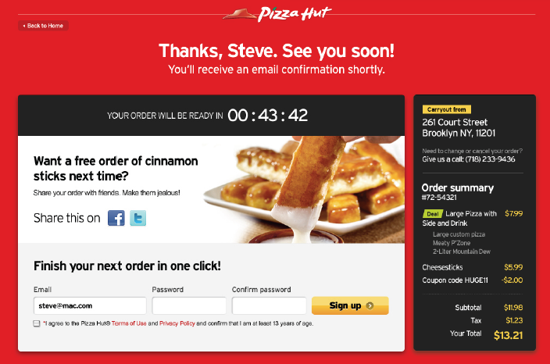

Other Guidelines

  - Ability to edit error messages to make them customer friendly.
  - Consider ability to allow user to login with federated login (e.g. user Facebook credential to login).
  - Ability to generate (or export the data) store performance, customer and order summary reports.

